Secluded Safari Special Package | Room Type | Package Inclusives | Package Price | Value Adds
RRomantic Safaari t  Getaway | Kewena Lsodge 5 star luxury  Stand-alone bedroom suites – max 2 adults, no children under 12 | Includes:  3 meals, afternoon tea 2 daily game drives | R2 750 per person sharing per night | - Spa voucher of R150 per adult per stay  - Mountain biking (bikes are provided)  - 30% discount voucher on all activities onsite
Bush Villa Breakaway with Family & Friends  ** Subject to a minimum 2 night stay ** | Exclusive-Use 3 or 4  luxury en-suite bedroom Bush Villas  Max 6 pax in 3 bed Villa Max 8 people in 4 bed villa | Full Board Includes:  3 meals, afternoon tea 2 daily game drives | R2 750 per person sharing per night | - Spa voucher of R150 per adult per stay  - Mountain biking (bikes are provided)  - 30% discount voucher on all activities onsite  - Junior Ranger Programme  - Private game drive for 4 or more
 |  | Breakfast, afternoon tea Game Drive | R1595 per person | - Private Game drive for 6 or more  - Spa voucher of R150 per adult per stay  - Mountain biking (bikes are provided)  - 30% discount voucher on all activities onsite  - Junior Ranger Program
GLAMPING GETAWAY  Take-over Gondwana’s Tented Eco Camp Exclusively for your Friends and Family  ** Subject to a minimum 2 night stay ** | 5 en-suite luxury bedroom tents sleeping up to 10 people  Main dining and lounge tent with pool and boma areas No children under 6 | Full Board: Includes all meals  Two game activities per day  Bring your own drinks or drinks provided at an additional cost | R12,000  per night (max 10 pax) | - Private field guide & game viewer  - Camp cook making all your meals  - Twice daily housekeeping  - Game drives and various conservation and bush skills activities  - Junior Ranger program for kids  - Bring your own drinks  - Exclusive Use of Camp
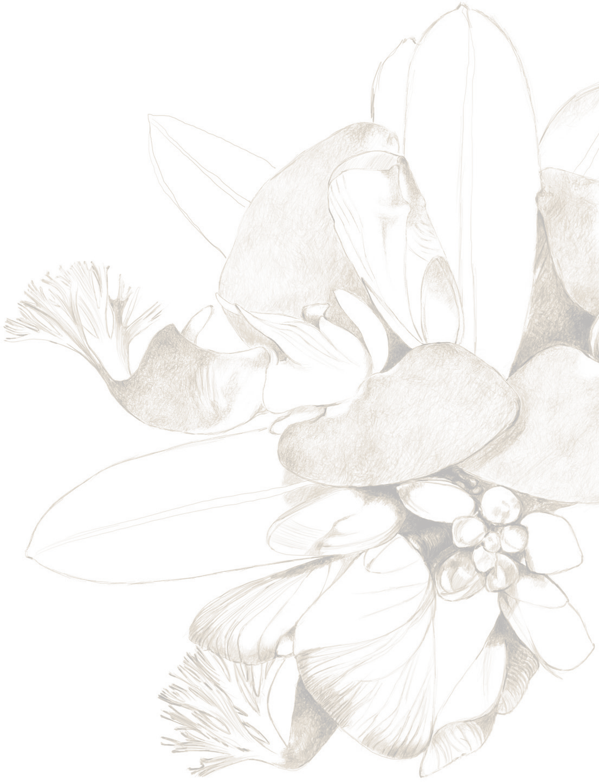

Secluded Safari Special Package | Room Type | Package Inclusives | Package Price | Value Adds
RGLAMPING GaETAWAY t  Take over one of Gondwana’s 3 new Pioneer Trail tented camps exclusively with your family & friends!  ** Subject to a minimum 2 night stay ** | es  Each camp has 4 luxury en-suite bedroom tents sleeping up to 8 people  Lounge & bar tent, dining tent and outdoor boma areas  No children under 12 | Full Board: Includes all meals  Two game activities per day.  Bring your own drinks or drinks provided at an additional cost | R10 000 per night  per Pioneer Camp sleeping up to 8 people | - Private field guide & game viewer  - Camp cook making all your meals  - Twice daily housekeeping  - Game Drives and various conservation and bush skills activities  - Junior Ranger program for kids  - Bring your own drinks  - Exclusive Use of Camp
SLACKPACKING ADVENTURE!  Walk Gondwana’s 3 Night Pioneer Trail exclusively with your friends and family  ** Set weekly departures on a Monday and Thursday  ** | Each camp has 4 luxury en-suite bedroom tents sleeping up to 8 people  Lounge & bar tent, dining tent and outdoor boma areas  No children under 16 | Full Board: Includes all meals and drinks and guided walking safari per day and a game drive | R15 000 per night  for up to 8 people exclusively. Can be modified to 2 nights staying in 1 camp | - Includes: 2 private Trail guides  - Camp Cook making all your meals  - Drinks included  - Housekeeping  - Includes transportation of your belongings and packed daypacks  - Special Rate: Book for 8 people and only pay for 6!  - Exclusive-use
Indulge & Relax at the Uber luxe and private Ulubisi House | Exclusive use, privately staffed deluxe lodge  Three en suite bedrooms  Sleeping 6 adults or 4 adults and 4 children Additional Loft apartment  Pool & hot tub | Full Board: Includes all meals  Two game activities per day  Bring your own drinks or drinks provided at an additional cost | R23 520 per night  Accommodates 4 adults and 4 children (under 12 years of age) or 6 adults  Maximum | - Private Chef & Butler  - Private Field Guide & Game Viewer  - Mountain biking  - Bush Walks  - Junior Ranger programme  - Spa voucher of R150 per adult per stay

